“Born Again”

Y13 UNIT 5 TEST 1

5.1 THERMODYNAMICS

BAHATI NJEMA!

Answer all questions
Total 50 marks

Name:………………………………………………………….

Mark for Section A……………./35

Mark for section B…………… /15

Total: ……………………………. /50

Grade……..
SECTION A
1. The table below lists a number of mean bond enthalpy values
Bond | Mean bond enthalpy/kJ mol–1
C—C  C==C  C—H  O—H | 348  612  413  463
(a) Explain the meaning of the term mean bond enthalpy.
.....................................................................................................................................
.....................................................................................................................................
.....................................................................................................................................
(3)
(b) Given that the enthalpy of combustion to form carbon dioxide and steam is
–2102 kJ mol–1 for propane and –1977 kJ mo1–1 for propene, determine the enthalpy change for the oxidation of 1 mol of propane to propene and steam
C3H8(g) + ½ O2(g) → C3H6(g) + H2O(g)
using equations or a cycle to support your answer.
.....................................................................................................................................
.....................................................................................................................................
.....................................................................................................................................
.....................................................................................................................................
.....................................................................................................................................
(3)
(c) State the number and type of bonds made and broken in the oxidation of propane to propene and steam. Use the mean bond enthalpies in the table above, together with your answer to part (b), to calculate the bond enthalpy of the O=O bond in the oxygen molecule.
Bonds broken...............................................................................................................
.....................................................................................................................................
Bonds formed..............................................................................................................
.....................................................................................................................................
Bond enthalpy of O=O ..............................................................................................
.....................................................................................................................................
.....................................................................................................................................
.....................................................................................................................................
(4)
(Total 10 marks)

2. Sodium bromide is formed from its elements at 298 K according to the equation
Na(s) + Br2(l) → NaBr(s)
The lattice dissociation enthalpy of solid sodium bromide refers to the enthalpy change for the process
NaBr(s) → Na+(g) + Br–(g)
The electron addition enthalpy refers to the process
Br(g) + e– → Br–(g)
Use this information and the data in the table below to answer the questions which follow.
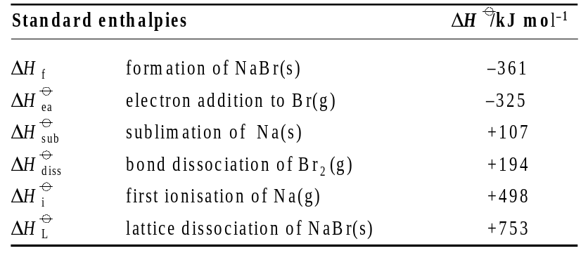

(a) Construct a Born-Haber cycle for sodium bromide. Label the steps in the cycle with symbols like those used above rather than numerical va1ues.

(6)
(b) Use the data above and the Born-Haber cycle in part (a) to calculate the enthalpy of vaporisation, ΔHvap of liquid bromine.
.....................................................................................................................................
.....................................................................................................................................
.....................................................................................................................................
.....................................................................................................................................
(3)
(Total 9 marks)
3. (a) The tables show values for the lattice enthalpy of the metal chlorides of the Group 1 and Group 2 metals.
Group 1 metal chloride | LiCl | NaCl | KCl | RbCl | CsCl
Lattice enthalpy/kJ mol–1 | –846 | –771 | –701 | –675 | –645

Group 2 metal chloride | BeCl2 | MgCl2 | CaCl2 | SrCl2 | BaCl2
Lattice enthalpy/kJ mol–1 | –3006 | –2493 | –2237 | –2112 | –2018
(i) Define the term lattice enthalpy.
...........................................................................................................................
...........................................................................................................................
(2)
(ii) Write the chemical equation for the reaction whose enthalpy change is equal to the lattice enthalpy of NaCl. Include state symbols in your equation.
...........................................................................................................................
(1)
(iii) Explain, in terms of the effects of ionic radius and charge, why the lattice enthalpy of the Group 1 metal chlorides decreases from LiCl to CsCl.
...........................................................................................................................
...........................................................................................................................
...........................................................................................................................
(3)
(iv) Explain, in terms of the effects of ionic radius and charge, why the lattice enthalpy of MgCl2 is greater than that of NaCl.
...........................................................................................................................
...........................................................................................................................
...........................................................................................................................
(3)
(Total 9 marks)
4. At 298 K, the enthalpy of solution of calcium chloride is –123 kJ mol–1 and the enthalpy
of lattice formation of this salt is –2255 kJ mol–1 The enthalpy of hydration of the calcium ion is -1650 kJ mol–1.
(i) Write equations using calcium chloride or its ions to illustrate the terms enthalpy of solution, enthalpy of lattice formation and enthalpy of hydration.
Enthalpy of solution........................................................................................
.........................................................................................................................
Enthalpy of lattice formation..........................................................................
.........................................................................................................................
Enthalpy of hydration.....................................................................................
.........................................................................................................................
(ii) Use the data above to determine the enthalpy of hydration of the chloride ion.
.........................................................................................................................
.........................................................................................................................
.........................................................................................................................
.........................................................................................................................
.........................................................................................................................
.........................................................................................................................
(7)
(Total 7 marks)
SECTION B
5. Use the data in the table below to answer the following questions.
Give chemical equations and calculate numerical values of ΔS wherever possible.
(a) At all temperatures below 100 °C, steam at atmospheric pressure condenses spontaneously to form water. Explain this observation in terms of ΔG and calculate the enthalpy of vaporisation of water at 100 °C.
(4)
(b) Explain why the reaction of 1 mol of methane with steam to form carbon monoxide and hydrogen (ΔH = +210 kJ mol–1) is spontaneous only at high temperatures.
(6)
(c) Explain why the change of 1 mol of diamond to graphite (ΔH = –2 kJ mo1–1) is feasible at all temperatures yet does not occur at room temperature.
(3)
(d) The reaction between 1 mol of calcium oxide and carbon dioxide to form calcium carbonate (ΔH = –178 kJ mol–1) ceases to be feasible above a certain temperature, Ts. Determine the value of Ts.
(2)
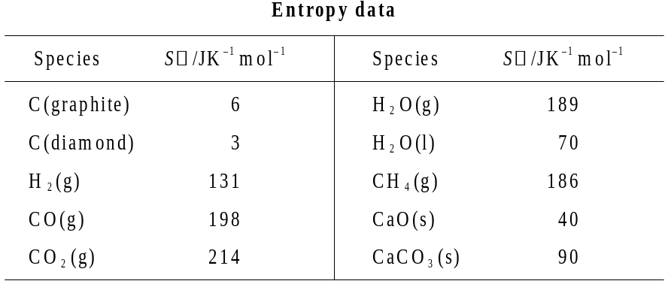
(Total 15 marks)
………………………………………………………………………………………………………...
………………………………………………………………………………………………………...
………………………………………………………………………………………………………...
………………………………………………………………………………………………………...
………………………………………………………………………………………………………...
………………………………………………………………………………………………………...
………………………………………………………………………………………………………...
………………………………………………………………………………………………………...
………………………………………………………………………………………………………...
………………………………………………………………………………………………………...
………………………………………………………………………………………………………...
………………………………………………………………………………………………………...
………………………………………………………………………………………………………...
………………………………………………………………………………………………………...
………………………………………………………………………………………………………...
………………………………………………………………………………………………………...
………………………………………………………………………………………………………...
………………………………………………………………………………………………………...
………………………………………………………………………………………………………...
………………………………………………………………………………………………………...
………………………………………………………………………………………………………...
………………………………………………………………………………………………………...
………………………………………………………………………………………………………...
………………………………………………………………………………………………………...
………………………………………………………………………………………………………...
………………………………………………………………………………………………………...
………………………………………………………………………………………………………...
………………………………………………………………………………………………………...
………………………………………………………………………………………………………...
………………………………………………………………………………………………………...
………………………………………………………………………………………………………...
………………………………………………………………………………………………………...
………………………………………………………………………………………………………...
………………………………………………………………………………………………………...
………………………………………………………………………………………………………...
………………………………………………………………………………………………………...
………………………………………………………………………………………………………...

